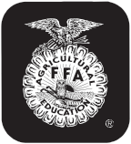

Rev. 1/13

County or FFA Chapter
Date

Phone No.

Last Name First Name(s) Age(s) (Jan. 1 current year) Mailing Address
Street or P.O. Box, Town, State, Zip

Club Name

NEBRASKA 4-H AND FFA DAIRY IDENTIFICATION AFFIDAVIT
See reverse side for important instructions and lease affidavit.

This animal is identified as 4-H OR FFA

BREED

REGISTERED GRADE

BRED BY EXHIBITOR: YES

NO

Name of Animal

Tattoo or Ear Tag No. Right Left

Registry No.

Date Born
Month Day Year

Need to have tattoo or tag identification for animals without distinct markings.

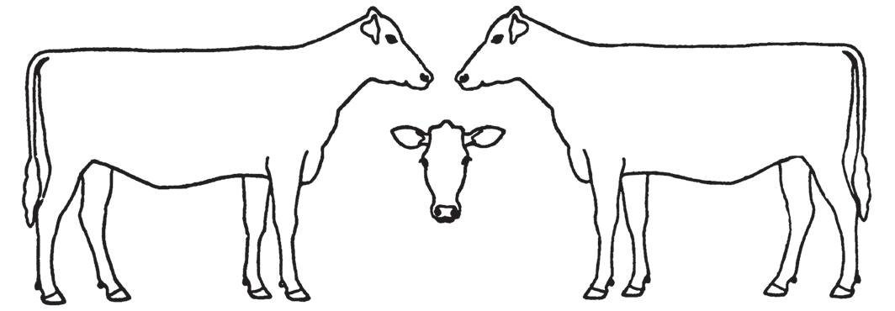Sketch markings and indicate color or attach photographs showing both sides of the animal.

I (we) certify that this is a 4-H or FFA project animal this year and that to the best of my (our) knowledge the above information is correct.

Date

Signature of 4-H or FFA Member(s) (At least one of those listed above must sign.)
This (these) youth has (have) submitted this livestock identification affidavit in accordance with all rules of the state and county 4-H Program or FFA Program and also has (have) successfully completed a Food Animal Quality Assurance program/test for this period.

Date

Parent Signature

Extension Staff or FFA Advisor

4-H Animal Exhibitor and Animal Project Regulations

Age of 4-H Exhibitor
A 4-H animal owner/exhibitor 8 to 18 years old on Jan. 1 of the current calendar show year is eligible to exhibit in 4-H-sponsored events. Exhibitors who are 10 as of Jan. 1 may exhibit at the State Fair and at the Ak-Sar-Ben Livestock Exposition. 4-H members may be certified for state and interstate shows if they meet age requirements for that event and have properly enrolled animals.

4-H/FFA Exhibits
Any animal shown as an FFA exhibit is ineligible to show as a 4-H exhibit by any exhibitor. An animal may be nominated for show participation in 4-H or FFA, but not both.

Animal Ownership
All dairy or dairy goat project animals must be owned:
a) solely by the 4-H exhibitor, or
b) the exhibitor in partnership with other member(s) of his or her immediate family. Only the name of the showman can be on the show entry. Immediate family is defined as members of a household, including parents, brothers and sisters, and youth in the care of the head of the household.
c) By someone outside the immediate family, but identified by the exhibitor, provided the exhibitor manages (cares for, feeds, trains, grooms, etc.), has use of the animal as a 4-H project animal at least 75 percent of the time during the project year and permission for the use of the animal is certified in the owner’s affidavit (below).

Registration Papers
For State Fair and Ak-Sar-Ben, registration papers must show one of the following:
a) the member’s name as owner, or
b) the name of the exhibitor and/or a co-owner who is a member of the exhibitor’s immediate family (see immediate family definition above), or
c) the family farm or ranch name or parent’s name, or
d) registered animals owned by someone outside the immediate family must be registered to the same person or farm name as listed in the owner’s affidavit below. The exhibitor must have registration papers available at the show for inspection by the show superintendent.

Identification of Animals
a) All animals must be individually identified, listed on the appropriate 4-H form and on file in the local Extension office by
June 15. Positive identification will consist of ear tag, tattoo or color marking identified by photo or drawing. One copy will be returned to the 4-H member to be brought to the show for inspection by the show superintendent.
b) A 4-H dairy animal may be identified in only one county. An animal cannot be shown in more than one county fair.

Species | Identification Method | State Identification Deadline* | Form
Dairy  Dairy Goat | Sketch, picture, tattoo or tag  Sketch, picture, tattoo or tag | June 15 of the current year  June 15 of the current year | 4HF109
*Individual counties and other shows or contests may use different information deadlines and/or rules, but for Nebraska State 4-H, these deadlines and information minimums must be met.

NOTE: USE BALL POINT PEN, PRINT LEGIBLY, BE CERTAIN OF INFORMATION BEFORE FILLING OUT FORM, CORRECTIONS ARE DIFFICULT TO MAKE.

Owner’s Affidavit

As owner of the animal described on the attached 4-H Dairy Identification Certificate, I certify that

has my permission to use this animal in 4-H projects.
Name

I understand the 4-H member must manage (including feeding, grooming, fitting, etc.) and have access to the animal at least 75 percent of the time during the project year.

Date Owner

Approved by Date
Extension Staff

