Welcome to 4-H Embryology!

Dear Parents or Caregivers,
For the next 21 days, your child will be participating in a Nebraska Extension 4-H Science project. Students will learn about the embryology of a chicken and the incubation process. Students will also be hatching chicks. Your child will be experiencing the miracle of life and will be excited to share it with you. If you would like to explore more information with your child, Lancaster.unl.edu/4h/Embryology is a great resource.

INCUBATION
Students may care for the fertilized eggs during the 21-day incubation period by:
-Turning the eggs three times each day.
-Pouring warm water in the incubator every day (to provide humidity).
-Maintaining a constant 100° temperature in the incubator.

CANDLING
A Nebraska Extension staff member candles the eggs after 10 days to allow students to see the development of the embryos.

HATCHING
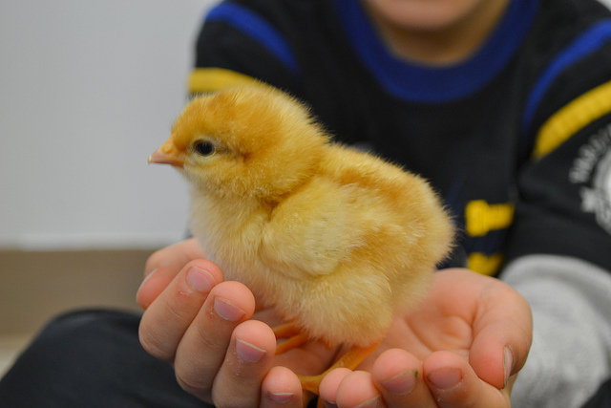
Students witness the amazing process of chicks hatching.

BABY CHICKS
Students care for the chicks in the classroom after they hatch by:
-Creating a “home” for the chicks.
-Providing the chicks with food and water.

HAPPY HATCHING!

Questions? Call (Insert Contact)
Embryology is a 4-H School Enrichment Project supported by
Nebraska Extension in (Insert) County
This program is offered by UNL Extension 4-H and operates in compliance with the UNL YAS policy

