University of Nebraska-Lincoln
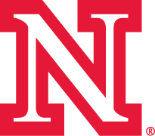

Moving to College:

It’s move-in day at the University of Nebraska-Lincoln!

The ________ (Mode of Transportation) is loaded with _________, _________, and ___________. (3 objects) My parents are __________ (adjective) that I’m leaving for college, so they bought me a new ________. (noun) I couldn’t be more _________ (adjective) about my new ___________ (same noun) because it can ______. (verb) While driving down the road, I came across a ______, (noun) and it made me feel ______. (feeling) After unloading the _________, (same mode of transportation) we ______ (action verb-past tense)to the door.
My roommate was very ________. (adjective) She brought _________, ________, & _________ (3 objects) to college. But when I saw her ______(object) I knew we would be great friends. My dad brought in my last ______ (item) and it was time to say _______ (pleasantry). After I hugged my parents, I saw there were _______ (noun) in my mom’s eyes. Unpacking, I found my mom left her _______ (personal belonging) in my room! Good grief.
I just know UNL is going to __________! (adjective)

