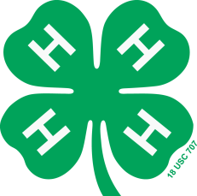
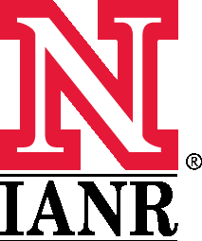
UNIVERSITY OF NEBRASKA – LINCOLN EXTENSION
Student Recruitment Funding Request

Person submitting request:
Date request submitted:
Email address: Phone:

Please complete the following information:

Event and Description:

Date(s) / Time(s) / Location(s) of Event:

Target Audience:

Goals / Objectives:

# of Students expected to attend/participate (include age and/or grade):

Budget Request: (Please detail how the funds will be used)

In order to receive funds, please mark the criteria check boxes below, that your event meets:
- There must be direct student contact with university faculty and/or staff
- Education needs to remain the primary focus, not entertainment
- Contact information needs to be collected
- An evaluation of the event should be performed

Following your event, we ask that you submit the following:
- Report of your event
- Nebraska Student Information Cards
- Photographs of your event
- Evaluation data you collect from participants

Submissions will be evaluated on creativity and student recruitment success.

Return Request Form to your District Coordinator:

Northeast District
Amy Topp, atopp2@unl.edu
Fax: 402-375-0102
410 N Pearl St, Ste C
Wayne, NE 68787-0102

Southeast District
Karna Dam, kdam2@unl.edu
Fax: 402-624-8030
1071 County Road G
Ithaca, NE 68033

West Central District
Brian Bosshamer, brian.bosshamer@unl.edu
Fax: 308-234-6319
1400 E. 34th (Fairgrounds)
Kearney, NE 68847-3992

Panhandle District
Cynthia Gill, cgill2@unl.edu
Fax: 308-254-6055
P.O. Box 356
Sidney, NE 69162-0356

April 2014

