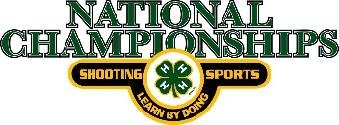
Air Pistol Equipment Check-in
2021 4-H Shooting Sports National Championships

Participants should complete as much of the information below as possible
prior to the event and bring two copies of this form with them to check-in.
Please print legibly
Competitor Name_______________________________ State__________
Last First
Competitor # ______________ Competitor Contact # _______________________

Coach’s Name _________________________ Coach’s Contact # ______________

Pistol | Mfg. | Serial # | Inspectors  Initials
.177 Wad Cutters Pellets: _______________
Firearm Weight
Pistol 3.3 lbs.

Trigger Weight

Pistol 500 gr/ 17.6 oz.

Shoes & Glasses: ______________
Inspector Initials

I agree the above information is correct and will remain
correct for the entire 2021 4-H National Championships.
I agree that any changes I make to my equipment will be
brought to the attention of the range officers and checked
to make sure it follows the guidelines for the 4-H National
Championships. Equipment may be checked at any time
before, during, or following competition to insure
compliance.

COMPETITOR SIGNATURE: __________________________________________

RANGE OFFICER SIGNATURE: _______________________________________

