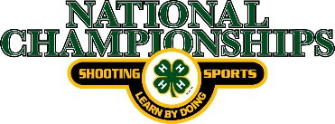
2021 4-H Shooting Sports National Championships
Air Rifle Equipment Check-in

Name: ___________________________________ Phone # _____________________________
Team: ______________________________
CMP Number________________________
Link to look up your CMP number or register for a number: https://ct.thecmp.org/app/v1/index.php# then click on quick competitor number lookup link
Sporter Air Rifle Equipment Check list
(Air Rifle Must be presented at Equipment check)
Make | Model | Serial Number | Rifle Weight (Official Use only) | Trigger Weight (Official Use only) | Approval Initials (Official Use only)

(All Equipment Must be presented at Equipment check)
No compression apparel
Item | Make/Brand | Approval Initials (Official Use only)
Shoes
Pants
Belt | 40 mm maximum in width
Glove
Sling
Kneeling Roll
Shooting Mat
Eye wear (Circle one) | Safety glasses or prescription eye glasses

Silhouette Air Rifle
(Air Rifle Must be presented at Equipment check)
Make | Model | Serial Number | Weight (Official Use only) | Approval Initials (Official Use only)

E-mail form to: mikej10x@diodecom.net when completed.

