HUNTING CHECK-IN

2021 4-H Shooting Sports National Championships
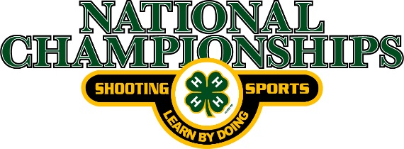

Name ________________________________________

Competitor # _________________

All shooting equipment used for the live-fire portion of the Hunting Skills discipline must be checked by the Range Officers before it is allowed to be used in competition. Complete this form and bring two copies with you to the check-in station at the National Championships.

Shooting Equipment | Serial Number | Brand/Model#/Type

Equipment may be checked at any time before, during, or following competition to ensure compliance.

