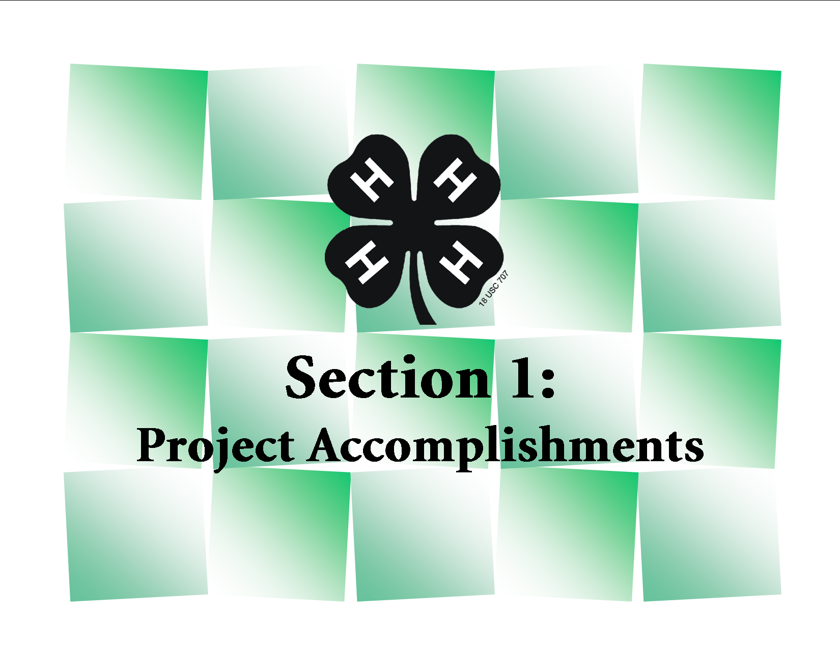

4-H Career Portfolio
Section 1: Project Accomplishments

Directions: In this section you will identify the project(s) you are taking. List what was done and/ or what you accomplished and what you learned through each project. Any experience related to the projects you are taking such as workshops, judging contests, presentations, speeches, camps specific to the curriculum areas should be located in Section 2.

Section 1A: Animal Science (Beef, Cat, Companion Animal, Dairy, Dairy Goat, Dog, Horse, Meat Goat, Poultry, Rabbit, Sheep, Swine, Veterinary Science)
Year | Project | List: What was done and what was learned. | List Award & Level
20_ _ | Breeding Beef | Raised 24 head of purebred Simmental Heifers and 1 Bull. During the project year I gained knowledge in pregnancy checking, artificial insemination and understanding EPD’s. Conception rate was 85%, compared to 60% last year. | 1 Ribbon - County Fair  1 Ribbon - State Fair

Section 1B: Communication & Expressive Arts (Communications, Photography, Theatre Arts)
Year | Project | List: What was done and what was learned. | List Award & Level
20_ _ | Photography Level III | Took 61 digital photos. Selected 4 of them to matte and frame. Discovered how different shutter speeds effects picture quality. I also learned that matte color can enhance the picture quality by lifting out certain colors out of the picture. Framed and matted my best photo for my Grandma. | 3 Ribbons – County Fair  1 Ribbon – State Fair  1 Photo for State Calendar

Section 1C: Consumer & Family Science (Clothing & Textiles, Consumer Management, Entrepreneurship, Heritage, Home Environment, Human Development)
Year | Project | List: What was done and what was learned.. | List Award & Level
20_ _ | Clothing Level 2 | Selected material & notions to construct a dress. Learned how to set in sleeves attach a neck facing, and put in a zipper. Completed a dress for my body type and wore it during the first week of school. | 2 Ribbons - County Fair  1 Ribbon - State Fair

Section 1D: Environmental Education & Earth Science (Conservation, Entomology, Forestry, Range, Shooting Sports, Wildlife)
Year | Project | List: What was done and what was learned. | List Award & Level
20_ _ | Shooting Sports | Participated in both rifle and BB shooting. Learned I am right eye dominant so I adjusted my shot accordingly. Increased my hits by 10%. Participated in 26 practice sessions with my 4-H club. | 1 Medal - County level

Section 1E: Healthy Lifestyles (Food & Nutrition, Health, Lifetime Sports, Physical Fitness, Safety)
Year | Project | List: What was done and what was learned. | List Award & Level
20 _ _ | Six Easy Bites | Experimented with 5 different cookie recipes. Discovered the differences between baking powder and soda. Made 12 dozen cookies. Developed a cookie recipe that I liked that was lower in sugar and fat. Exhibited 2 food entries at the County Fair and 1 at State Fair. | 2 Ribbons - County Fair  1 Ribbon - State Fair

Section 1F: Leadership & Citizenship (Citizenship and Leadership)
Year | Project | List: What was done and what was learned. | List Award & Level
20_ _ | Public Adventures | Planned a party with four club members for 12 Abuse Center children. Helped organize a collection drive that generated 50 cell phones for the Center. Developed skills to plan a party on a small budget. Learned how to identify places in need in my community.
20_ _ | Jr. Leader | Led club community service project on making care baskets for the homeless shelter. Held 3 meetings with 10 club members to set and accomplish goals. Learned how to organize a fund drive and how to manage committees. Ten care baskets were made and delivered to the homeless shelter.

Section 1G: Plant Science (Crop Production, Horticulture)
Year | Project | List: What was done and what was learned. | List Award & Level
20_ _ | The World of Flowers | Hand pollinated pansies to develop new color variety. Determined difference between 3 soil types. Learned how to ribbon soil. Determined soil was lacking in nitrogen and added organic matter to one flowerbed. Therefore the soil quality in my flower beds improved resulting in larger blossoms. | 2 Ribbons and hoe - County Fair

Section 1H: Science & Technology (Aerospace, Computers, Electricity, Engineering, Small Engines, Welding, Woodworking)
Year | Project | List: What was done and what was learned. | List Award & Level
20_ _ | Woodworking Unit II | Drew up plans and built a quilt rack. Learned many staining techniques and sanding tricks from my Grandpa and learned how to use a miter saw. My completed project matched the furniture in our family room. | 1 Ribbon - County Fair

4-H Career Portfolio
Section 1: Project Accomplishments

Section 1A: Animal Science (Beef, Cat, Companion Animal, Dairy, Dairy Goat, Dog, Horse, Meat Goat, Poultry, Rabbit, Sheep, Swine, Veterinary Science)

Year  List past to present | Project | List: What was done and what was learned. | List Award & Level

Section 1B: Communications & Expressive Arts (Communications, Photography, Theatre Arts)
Year  List past to present | Project | List: What was done and what was learned. | List Award & Level

Section 1C: Consumer & Family Science (Clothing & Textiles, Consumer Management, Entrepreneurship, Heritage, Home Environment, Human Development)
Year  List past to present | Project | List: What was done and what was learned. | List Award & Level

Section 1D: Environmental Education & Earth Science (Conservation, Entomology, Forestry, Range, Shooting Sports, Wildlife)
Year  List past to present | Project | List: What was done and what was learned. | List Award & Level

Section 1E: Healthy Lifestyles (Food & Nutrition, Health, Lifetime Sports, Physical Fitness, Safety)
Year  List past to present | Project | List: What was done and what was learned. | List Award & Level

Section 1F: Leadership & Citizenship (Citizenship, Leadership)
Year  List past to present | Project | List: What was done and what was learned. | List Award & Level

Section 1G: Plant Science (Crop Production, Horticulture)
Year  List past to present | Project | List: What was done and what was learned. | List Award & Level

Section 1H: Science & Technology (Aerospace, Computers, Electricity, Engineering, Small Engines, Welding, Woodworking)
Year  List past to present | Project | List: What was done and what was learned. | List Award & Level

