DATE: August 13, 2026
TO: 4-H and FFA State Fair Livestock Exhibitors
FROM: Brandy Schulze, 4-H Livestock Superintendent
Ryan Hassebrook, FFA Livestock Superintendent

Thank you for choosing to exhibit livestock at the Nebraska State Fair! This letter is to inform you of State Fair procedures that apply to all 4-H and FFA livestock exhibitors. If you have specific questions about your livestock entries, please contact your county 4-H Extension Staff or FFA Advisor.

Map:
Here is the official map of the 2026 Nebraska State Fair.

2026 Livestock Schedules:
2026 FINAL Detailed Livestock Schedule Updated: 7/17/26
2026 Livestock Arrival/Departure Schedule Updated: 7/7/2026

Exhibitor Entry to Grounds, Unloading, and Traffic Flow:
- All exhibitors will enter the east entrance to the Livestock Trailer Lot from Stolley Park Road. Livestock Trailer Lot is a grass lot located south of the fairgrounds on Stolley Park Road. There will be feather flags to guide exhibitors to the correct gate.
- Before entering the fairgrounds, all livestock will be subject to examination by a veterinarian. The veterinarian will provide the exhibitor with a card after inspection. A (CVI) Certificate of Veterinary Inspection (CVI) is not required for Nebraska origin livestock.
  - Sheep and goat exhibitors will be required to remove blankets for inspection.
- After the veterinarian check, exhibitors will pick up their exhibitor packet at the Livestock Check-In Trailer.
- After approval from security to enter, swine exhibitors will proceed to Gate # 3 and cattle, sheep and goat exhibitors will proceed to Gate #4. Volunteers will be available to help navigate exhibitors to the correct location.
- Exhibitors will unload and exit to the east side of their respective barn and exit through Gate #2. Note: Exhibitors should move their vehicles prior to setting up their area to allow other exhibitors to unload their tack and livestock. Please be considerate of your fellow livestock exhibitors. There will be people in the barns guiding exhibitors to the stalls/pens. Exhibitors are asked to be unloaded in 30 minutes to keep the flow of traffic moving.
- After unloading and exiting the grounds, exhibitors will drop their trailer off in the Livestock Trailer Lot. A permit is not required to leave your trailer in Livestock Trailer Lot.
- Vehicles with an exhibitor permit may park in Exhibitor Lot 3A (lot west of Swine Barn). All overflow exhibitor parking permit holders will shift to lot 3B (Livestock Trailer Lot). Vehicles without an exhibitor parking permit will park in general parking. Exhibitor parking permits will be available to purchase at Livestock Check-In Trailer.

Note: Beginning Friday, August 28 at 9:00 AM CT, all exhibitors will have to have a wristband or admission ticket to enter the grounds, even for dropping off tack.

Unloading Map:
Exhibitors can find other Livestock Exhibitor Maps online.

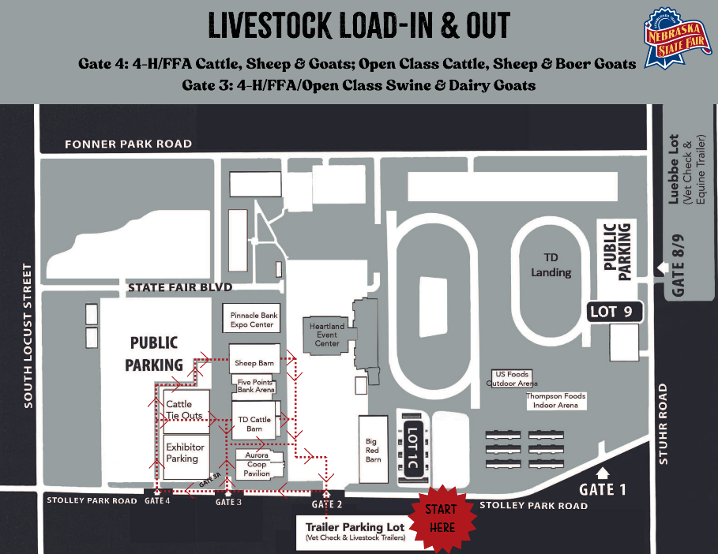

Livestock Check-In Trailer Hours (CST):
Exhibitors can arrive during open hours. If an exhibitor arrives with their livestock outside of vet check hours, they will be unable to enter the grounds. Please review the arrival schedule to note check-in and in place times. 2026 Livestock Arrival/Departure Schedule Updated: 7/7/2026

Health Certificates:
A (CVI) Certificate of Veterinary Inspection (CVI) is no longer required for Nebraska origin livestock. Please refer to the State Fair Livestock Health Requirements for additional information.

Rules:
Be sure to read and abide by all rules outlined in the 4-H & FFA General Livestock Rules, each species-specific rules for 4-H and FFA and the State Fair General Livestock Rules & Regulations as well as the 4-H or FFA fairbook.

Exhibitor Packets:
Every livestock exhibitor will receive an exhibitor packet. The packet will include important documents, weigh cards, back tags, and promotional material. If you find you are missing something, you can visit with the volunteers in the Livestock Office.

For exhibitors who purchased any extra discounted items such as gate tickets, parking permits, stand/chute permits and wristbands, you may pick up your packet at any time during the open trailer hours. Packets will not be available to pick up until the first arrival time.

Exhibitor Shirts
- 4-H livestock exhibitors can pick up their shirt in the livestock office.
- FFA exhibitors can pick up their shirt in the livestock office during the second weekend only. FFA shirts will not be available on the first weekend.

Check-in:
All entries must be checked in during the assigned check in time to exhibit at the State Fair. The Livestock Trailer Lot Vet Check is not your show check-in, so please review the schedule to confirm where and when you will have your species check-in for 4-H or FFA. If you miss check in, you will be ineligible to show.

Before coming to State Fair, ensure that the tag and/or tattoo are visible and in the ear.

Stall Assignments and Guidelines:
Stalling assignments will be emailed to this livestock exhibitor listserv and to FFA Advisors and 4-H Extension Staff as they become available. If you have any questions or concerns about your assignment, please contact your local 4-H Extension Office or the local FFA Advisor.

Cattle are required to tie out after 9:00 PM. There will be flexibility in the event of bad weather. No generators, pens or chutes are allowed in the tie out area. Tie outs will be monitored with security staff.

Reminder, if you are a beef exhibitor, please flatten out the bedding in tack/chute areas and put equipment on top of bedding and NOT pile it up in other stalls. If there is not bedding in a stall, do not place bedding in that area as it is a tack stall.

Note: Swine will be stalled two hogs per pen. Goats will be stalled 4 per pen and sheep will be stalled 3 per pen.

Additional Electricity Available:
Please continue to use common sense in the equipment you bring - though there is sufficient power available, it is not unlimited. Keep extension cords to a minimum! DO NOT have cords lying across aisles or in water. All generators must be kept outside the barn.

Livestock Insurance:
Because of heat, stress or other conditions, an animal occasionally dies during transit or at the State Fairgrounds. Some insurance companies do offer special insurance for exhibitors to cover their animals during transit and exhibition. If you are interested in assuring that such a loss will be covered, contact a local insurance agent. There is no insurance coverage (through State Fair, 4-H or FFA) for this type of loss.

Bedding and Feed Service:
All Feed and Bedding needs will be handled by Aurora Cooperative. You can pre-order feed and additional bedding by contacting Jeff Meradith with Aurora Cooperative at 402-362-2471. You can also visit their feed store during the State Fair. Nebraska State Fair will not provide equipment to load/unload/transport any type of hay, bedding, and feed.

Bulk bedding will be provided in the cattle barn and tie-out area. However, for cattle exhibitors, the same common bulk bedding will be used throughout the fair. As a courtesy to the next group arriving, beef exhibitors are encouraged to clean out their tie-out area before leaving. FFA cattle, you may want a little additional bedding to freshen up your stall when you arrive second weekend.

REMINDER: Bedding will not be supplied for the Sheep, Swine and Goats as in the past. Sheep, Swine and Goat exhibitors will be responsible for providing their own bedding. Bedding may be purchased from Aurora Cooperative, located west of the Cattle Barn, open daily with payment of cash, check, or credit/debit card.

Generators:
No generators will be allowed in the barns or in the tie area at any time. Generators will be allowed only outside the barns.

Fans, Extension Cords and Electrical Devices:

All fans, extension cords and electrical appliances used in the livestock barns must have a ground, must have safe wiring and must be in safe working condition. All fans used in the barns must have a protective screen (front and back). Free standing fans (butt fans) or portacools will not be allowed. Refer to rule #30 State Fire Marshall for further clarification. Hanging fans will only be allowed when attached to the tie rails or to supports attached to the tie rails. Only 1 fan per animal! The superintendent has the express authority to determine if any fan, extension cord or other electrical device is allowed.

Beef Blocking Chutes and Sheep/Goat Stands:
Beef blocking chutes permits, and sheep/goat stand permits were pre-sold during entry. A limited number of permits will be available for purchase in the Livestock Office. Exhibitors will be asked to remove chutes without proper tags or in non-designated spaces. No blocking chutes will be allowed in the swine barn.

Dogs:
Due to requirements of the liability insurance carrier and policy of all major livestock shows, no dogs are allowed on the Nebraska State Fairgrounds, in parking lots or in buildings other than those for direct competition or service animals.

Final Drive: Champion Market Selection and Parade of Breeding Champions:

To highlight the outstanding Nebraska 4-H and FFA members, their families, and their accomplishments there will be a Final Drive Champion Market Select and Parade of Breeding Champions on both weekends. The market animals will not have their champions selected at the conclusion of the market show but will be selected in the Final Drive. In addition, the breeding champions (champion and reserve champion) will be paraded and recognized prior to those market animals being selected. Please join us for the big events!

4-H Final Drive: Sunday, August 30 at 4 PM CT
FFA Championship Selection: Monday, September 7 at 3:30 PM CT

Livestream:

State Fair we will be livestreaming goats, sheep, cattle and swine shows for 4-H and FFA. It will be linked on the website, https://www.statefair.org/livestock-exhibitors/, through the State Fair Livestock Facebook page, https://www.facebook.com/NSFLivestockExhibitors and through Ringside Live | Live Webcasting.

4-H Livestock Release:
Breeding Beef, Breeding Swine, Breeding Ewes and Poultry can begin release on Saturday, August 29 between the hours of 6 PM - 9 PM CT. Beef exhibitors will be able to drive through the barn if breeding beef show is concluded. All animals will need to stay in place until Sunday, August 30 until 11 AM. At 11 AM, all animals begin to load out. Exhibitors will not be able to drive through the barns until the conclusion of the show(s). Until the conclusion of the shows, beef exhibitors will access the south side of the beef barn and exit gate #2 and sheep/goat exhibitors will have access to the north side of the sheep/goat barn and exit gate #2. All 4-H livestock, rabbits and poultry must be out of the barns on Sunday, August 30 by 8:00 PM CT.

FFA Livestock Release:
Any FFA livestock that is finished showing on Sunday, September 6 may begin that evening between the hours of 6 PM - 9 PM CT. Beef exhibitors will be able to drive through the barn if the breeding beef show is concluded. All animals will need to stay in place until Monday, September 7 until 11 AM. At 11 AM, all animals begin loading out. Exhibitors will not be able to drive through the barns until the conclusion of the show(s). Until the conclusion of the shows, beef exhibitors will access the south side of the beef barn and exit gate #2 and sheep/goat exhibitors will have access to the north side of the sheep/goat barn and exit gate #2. All FFA livestock, rabbits and poultry must be out of the barns on Monday, September 7 by 7:00 PM CT.

