DATE: August 14, 2026

TO: State Fair 4-H Rabbit & Poultry Exhibitors

FROM: Brandy Schulze, 4-H Livestock Superintendent

We have received your 4-H rabbit and poultry entries and are excited that you will be joining us at the 2026 Nebraska State Fair! This letter is to inform you of State Fair procedures that apply to all 4-H small animal exhibitors. If you have specific questions about your entries, have your County Extension Educator contact one of these people:

Poultry Superintendent: Mirissa Scholting, mscholting2@unl.edu
Poultry Assistant Superintendent: KateLynn Ness, kness2@unl.edu

Rabbit Superintendent: Molly Brandt, molly.brandt@unl.edu
Rabbit Assistant Superintendent: Sheena Davidson, sheenadavidson@unl.edu

Map:
Here is the official map of your 2026 Nebraska State Fair. Exhibitors can find other Livestock Exhibitor Maps online.

Schedule:
- The livestock schedules for the Nebraska State Fair can be found here: https://www.statefair.org/livestock-exhibitors/
- Check in for poultry will be from 5:00 PM-8:00 PM CST on Friday, August 28 in the sheep barn on the east end by the poultry area. Look for signs for the specific location. Please note, the vet check in the Livestock Trailer Lot is not the official 4-H check-in. You will need to turn in your entry cards to your respective 4-H check-in.
- Check in for rabbits will be from 8:00 AM-10:30 AM CST on Saturday, August 29 in the sheep barn at the east end by the rabbit area.
- All entries must be checked in during the assigned check in time to exhibit at the State Fair. If you miss check in, you will be ineligible to show.
- All rabbits and poultry must be housed at the State Fair from check in to the release time.

Release Time

4-H Poultry exhibitors may begin release from 6:00 PM CST - 9:00 PM CST on Saturday, August 29. 4-H Poultry and Rabbits may begin release at 11:00 AM CST on Sunday, August 30. All animals must be out by 8 PM on Sunday, August 30.

Health Requirements (Nebraska Origin)
- 4-H rabbits do not require a Certificate of Veterinary Inspection (CVI). Be prepared to implement biosecurity practices to protect from Rabbit Hemorrhagic Disease.
- 4-H poultry will not require any additional testing requirements.
- Please review the Nebraska State Fair Animal Health Requirements for out-of-state origin animals.
- Before entering the fairgrounds, all poultry and rabbits will be subject to examination by a veterinarian.

Exhibitor Entry to Grounds, Unloading and Traffic Flow:
- Coming from either the east or west, enter Livestock Trailer Lot (south of the fairgrounds) from Stolley Park Road.
- Before entering the fairgrounds, all poultry and rabbits will be subject to examination by a veterinarian.
- After the veterinarian check, exhibitors will need to pick up their exhibitor packet at livestock check-in trailer.
- After you leave Livestock Trailer Lot, enter Gate #4 and proceed past the tie outs to the west gate of the sheep barn.
- Unload on northeast side of sheep barn.
- After dropping off your animals, travel east and south to exit through Gate #2 and park in exhibitor or general parking.
- If you have purchased an exhibitor parking permit, you may park in the exhibitor parking lot (3A) by entering Gate #3. If lot 3A is full, exhbitors with permits may also park in lot (3B) Livestock Trailer Lot to the south of the fairgrounds. Livestock Trailer Lot is off the grounds so entry through the walk through gate is required with a pass or admission fee. Trailers will not be allowed in the Exhibitor Parking Lot 3A.

Note: Beginning Friday, August 28 at 9:00 AM CT, all exhibitors will have to have a wristband or admission ticket to enter the grounds, even for dropping off tack.

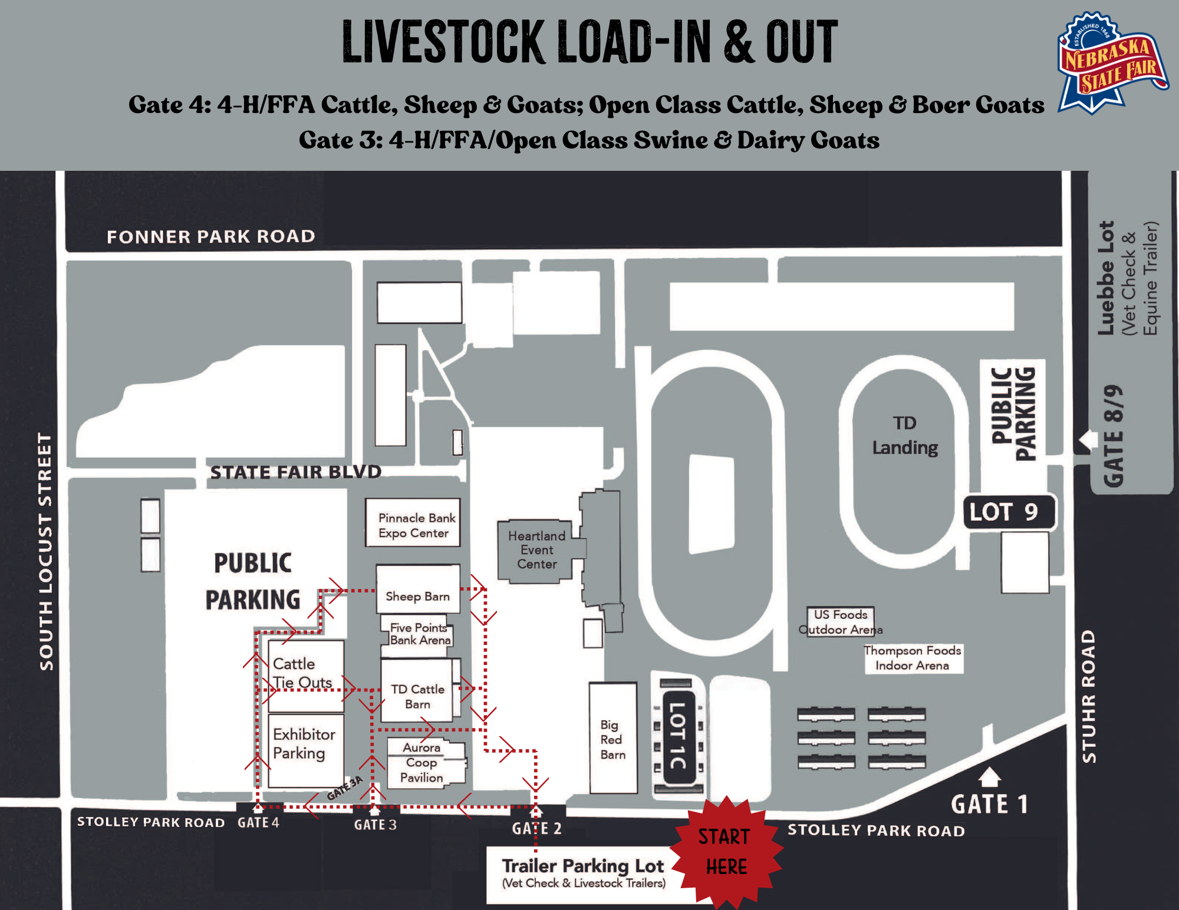
Livestock Check-in Trailer Hours
Reminder, exhibitors can only pick up their exhibitor packets during the following hours.

Thursday, August 27: 8:00 AM CST - 8:00 PM CST
Friday, August 28: 8:00 AM CST- 8:00 PM CST
- Poultry must be in place by 8:00 PM CST on Friday
Saturday, August 29: 8:00 AM CST – 10:30 AM CST
- Rabbits must be in place by 10:30 AM CST

4-H Livestock Office Hours
- Thursday, August 27: 8:00 AM - 8:00 PM CST
- Friday, August 28: 8:00 AM CST - 8:00 PM CST
- Saturday, August 29: 7:00 AM CST - 7:00 PM CST
- Sunday, August 30: 7:00 AM CST- 4:00 PM CST

State Fair 4-H Exhibitor Shirt
Exhibitors can pick up their State Fair exhibitor t-shirt during office hours at the Livestock Office which is located on the west side of the Five Points Bank Arena.

Showmanship Time Limit:

Poultry: Maximum time is five minutes.
Rabbit: Maximum time is four minutes.

Items to Bring:

- Each exhibitor is to bring their own bowls for water and feed. Bowls and feed will not be provided in 2026.
- Exhibitors are required to wear the official State Fair 4-H t-shirt available at the livestock office. Solid blue jeans are required. No hats, caps or other types of headgear are to be worn. Exhibitors shall not display any local, county or club identification.
- Cardboard or other barriers may be used and encouraged to help separate rabbits and poultry between cages. Barriers will not be supplied by the Nebraska State Fair and must be provided by the 4-Her.

State Fair App
Download the 4-H at the Nebraska State Fair App for easy access to the schedule of 4-H events, 4-H live animal show programs and contest schedules, results, and so much more! All live animal programs will be posted on the app and posted near the show arena. Link to app: https://4h.unl.edu/state-fair

Additional Reminders:

Rabbit
- Rabbit exhibitors were allowed the option to pre-enter up to 10 rabbits into ShoWorks but can only exhibit 6 rabbits at the State Fair. Those additional rabbits that were entered are eligible for potential substitutions.
- All rabbits must be entered and exhibited in a breeding or market class; this includes rabbits used for showmanship. A rabbit cannot be used only for showmanship.
- All rabbits, except fryers, must have permanent ID numbers or names tattooed in their ear with a pin tattoo pliers or rotary tattoo pen and tattoo ink (permanent marker numbers written in the ears of the rabbits are NOT permanent ID numbers). These ID numbers or names must match the State Fair entry list in order to be eligible to show.
- All rabbit tattoos will be reviewed at check in. Rabbits whose tattoos are not legible or do not match the registration information will not be allowed to show at the State Fair.
- Please leave large cages for those with large breeds. Cages will be marked for those who have large breed rabbits. Cage selection is first come, first serve.
- Please cut off all zip-ties on your cage(s) prior to leaving the fair.
- Wood shavings will be provided for rabbit exhibitors to use as bedding under cages.

Poultry

- A 4-H member is limited to exhibiting 6 live bird entries (egg production trios are considered one entry). Egg entries are not considered in the 6 bird limit. Egg entries are limited to one dozen per exhibitor. Do not refrigerate prior to exhibiting eggs.
- POULTRY SUBSTITUTIONS: Substitutions of poultry exhibits are only allowed if the substitution is within the same division AND was also nominated in the state fair entry database by August 10. For example, a bantam chicken can only be substituted for another bantam chicken. A bantam duck could NOT be substituted for a bantam chicken. Divisions are: Large Fowl, Bantam, Waterfowl, and Production Fowl.
- Cage selection is first come, first serve but please leave large cages open for large poulty exhibits.
- Please cut off all zip-ties on your cage(s) prior to leaving the fair.
- Wood shavings will be provided for poultry exhibitors to use as bedding under cages.

Dogs:
Due to requirements of the liability insurance carrier and policy of all major livestock shows, no dogs are allowed on the Nebraska State Fairgrounds, in parking lots or in buildings other than those for direct competition or service animals. See Nebraska State Fair General Livestock Rules and Regulations for further information.

