DATE: August 25, 2026

TO: State Fair 4-H Dog Show and Skill-a-thon Exhibitors
FROM: Brandy Schulze, 4-H Livestock Superintendent

We have received your 4-H Dog Show entries and are excited that you will be joining us at the 2026 Nebraska State Fair on Sunday, September 6! Here is information for the Dog Show exhibitors and Dog Skillathon exhibitors. Please read the enclosed information for your areas and refer to the additional information available from the web links. If you have specific questions about the 4-H State Fair Dog Show or 4-H Dog Skillathon Contest, please contact the following people.

4-H Dog Show Superintendent: Sarah Fanning, Extension Educator, sfanning3@unl.edu
Companion Animal Specialist and 4-H Dog Skillathon Contest: Dr. Lisa Karr, lisa.karr@unl.edu
4-H Companion Animal Extension Assistant: Cindy Wolverton, cwolverton3@unl.edu

Dog Vaccination Papers:
All dog vaccination records should be emailed immediately upon entry to the State 4-H Dog Show or by August 10. Please alert your county office of your State 4-H Dog Show entry and submit your vaccination papers to Dr. Lisa Karr. SF 263 Forms must be received and checked before youth can show at State Fair. Questions about vaccination forms should be directed to Dr. Lisa Karr (lisa.karr@unl.edu). A copy of the SF 263 forms will be provided to the State Veterinarians working at the Equine Check-In Trailer for approval. This is the health paperwork (SF 263) that is required for 4-H Dogs. All vaccinations must be in effect at the time of the State Fair Dog Show.

Map:
Here is the official map of your 2026 Nebraska State Fair.

General Schedule (Sunday, September 6):

- 6:00 AM CST: Animal Vet Check opens in Equine Trailer Luebbe Lot (Stuhr Road)
- 7:00 AM CST: Registration for all 4-H Dogs will open, Thompson Foods Indoor Arena
- 8:00 AM CST: Obedience and Showmanship
- 8:30 AM CST: Dog Skillathon Contest begins (must start by 10:00 AM, must end by 2:00PM), Thompson Foods Indoor Arena
- 9:30 AM CST: Agility begins
- Estimated 10:30 AM CST-Rally starts upon completion of obedience classes

- End of Show: All supplies & dogs must be removed from Thompson Foods Indoor Arena immediately following the conclusion of the show.
Equine Check-in Trailer Hours, Exhibitor Packet and Gate Passes:
All 4-H Dog Exhibitors receive a single-day admission pass with their State Fair entry. and a single-day parking permit for the Equine Trailer Lot (per vehicle). Gate passes, livestock parking permits, and any additional items such as admission wristbands or gate passes will be found in your Exhibitor Packet.

IMPORTANT: Exhibitor packets can be picked during open hours at the Livestock Check-In Trailer located off Stolley Park Road on Thursday, August 27- Monday, August 31. The Livestock Check-In Trailer hours can be found here: 2026 Livestock Arrivals & Departures. In the afternoon on Monday, August 31, any leftover exhibitor packets will be moved to the Equine Check-In Trailer located in the Luebbe Lot off Stuhr Road. Exhibitors may pick up their exhibitor packets in the Equine Check-In Trailer during their open hours. The Equine Check-In Trailer hours can be found here: 2026 Equine Trailer Schedule. Note: Passes will not be mailed to Extension Offices. Exhibitors will want to allow plenty of time for driving, traffic flow and parking.

Hours of operation on Sunday, September 6 will be from 6:00 AM CST until 8:00 AM CST.

Parking and Unloading Information:

Parking: There are a couple of options for dog exhibitors to park for free. Exhibitors can park east of Stuhr Road in the Luebbe East public parking. The other option and most convenient option for families is the free public parking lots west of Stuhr Road (see map below). Note: Exhibitors are not required to have a parking permit to park during the State Fair so there will not be a special permit in the exhibitor packet.

Unloading: Exhibitors may enter through the parking lot entrance on Stuhr Road and drop off crates and supplies just east of the Thompson Foods Indoor Arena (see map). Parking will not be permitted in this area. All vehicles must be unloaded and moved to the free public parking lot immediately north of the arena after drop off or pick up.

When unloading, be sure that valuable items and vehicles are not left unattended. While on the State Fairgrounds, dogs must always be on a leash or in a kennel. Dogs will be allowed to walk between the parking lots and the Thompson Foods Indoor Arena.

Note: If you have a break between show times and would like to explore the fairgrounds, do not leave your dog unattended. Exhibitors may rotate supervision duties with family members, coordinate with other families from their county, or work with exhibitors crating in the same area to take turns watching dogs. Be sure to exchange emergency contact information.

Unloading and Parking Map-2026

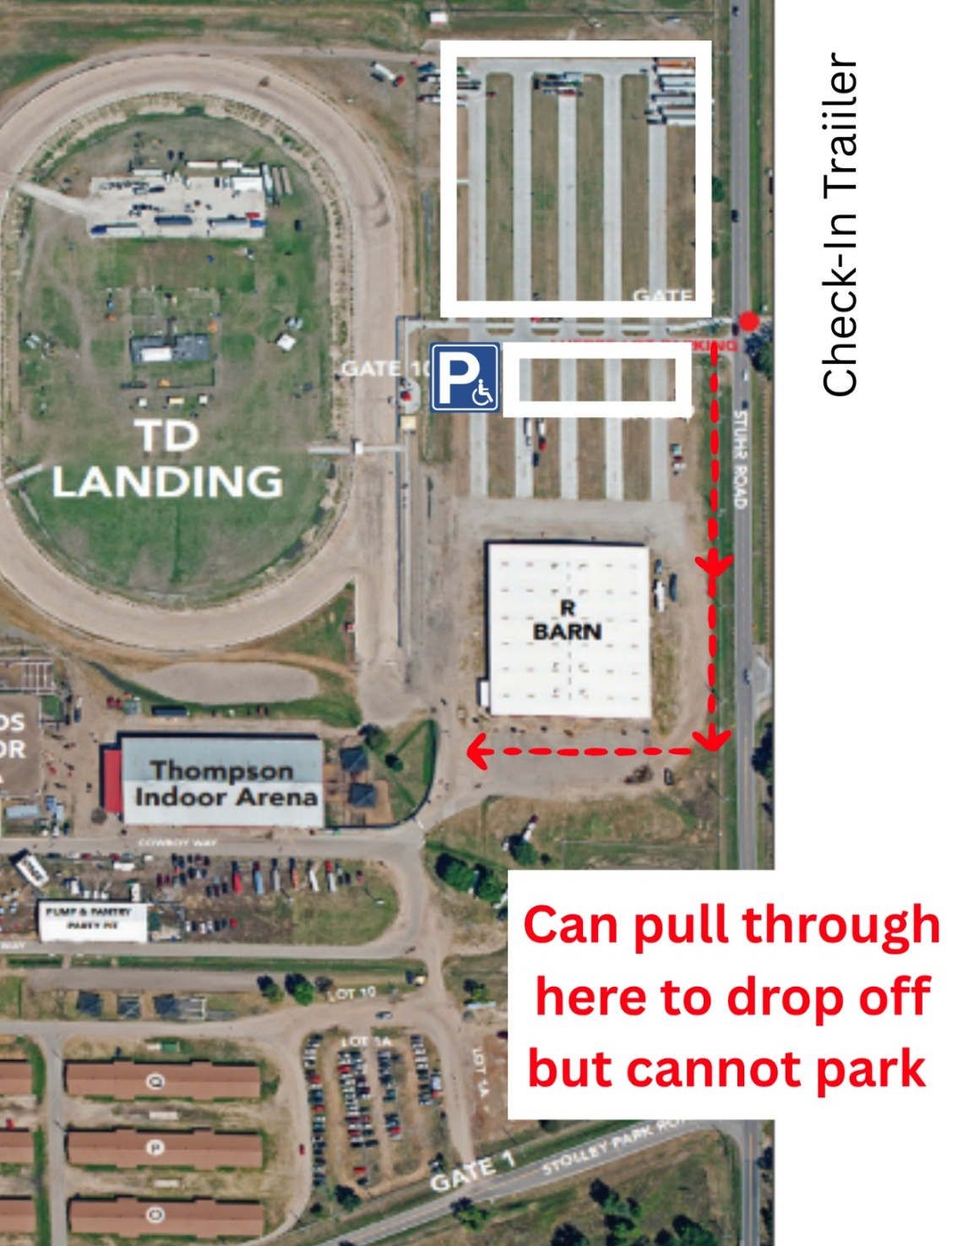
4-H Dog Show
Gate 1: Judge Parking
Free Public Parking Lots
Registration:
All dog show exhibitors will check-in at the registration table found in the Thompson Foods Indoor Arena . Exhibitors will enter the Thompson Foods Indoor Arena through the southwest doors of the building. They should then check in at their assigned ring(s) 30 minutes prior to judging.

REMINDER: If a youth member accidentally registered for the incorrect class, they have until 8:00 a.m. the morning of the show to alert dog superintendents of the error and change to the appropriate class. After 8:00 a.m., youth members that registered for a higher difficulty class will be allowed to choose if they would prefer to scratch or compete in the class they registered in (ex. Registered in Novice A but should be in Beginning Novice A). Youth members that registered for a lower difficulty class will be automatically scratched for that event (ex. Registered in Beginning Novice A but should be in Novice A).

Dress Code:
Exhibitors are required to wear the official 2026 State Fair 4-H T-shirt. If you are only exhibiting in the dog show, exhibitors will pick up their shirt at the registration table in the Thompson Foods Indoor Arena. If you are a youth exhibitor participating in other animal shows, please pick up your shirt in the Livestock Office. Solid blue jeans are required. No hats, caps or other types of headgear are to be worn. Exhibitors shall not display any local, county or club identification. Closed toed shoes with a non-slip sole are required. No flip-flops or sandals are allowed. Exhibitors should always look neat, clean and well-groomed. You may consider wearing shoes that would be appropriate for running/movement in sand/dirt in the arena.

Any distractions, such as loose hair, distracting jewelry, clothing other than that directed by the dress code or show superintendent, and caps or hats will result in deduction of points by the judge.

Crating:
There will be areas to crate within the Thompson Arena. These spaces will be on a first-come, first served basis. Dogs will not be allowed in the bleachers. You may consider bringing a small battery powered clip on fan for your crate if you have one.

Dog Potty Areas:
It is the dog exhibitors’ responsibility to pick up after their dogs at all times. Dogs soiling in the show ring (during a class) will be lowered one ribbon placing. Dogs soiling anywhere on the show grounds with no pickup will be disqualified from all entered classes on that show day regardless of the person who is holding the dog leash. Use a plastic bag to clean up after your dog and put the bag in the trash can.

Be sure to take your dog outside often to minimize accidents. Frequent checks will allow exhibitors and their dogs the opportunity to perform to their best ability. Clean up after your dogs on the fairgrounds. Exhibitors are welcome to use any grass area outside of Thompson arena for potty breaks for their dog(s).

State Fair App
Download the 4-H at the Nebraska State Fair App for easy access to the schedule of 4-H events, 4-H live animal show programs and contest schedules, results, and so much more! All live animal programs will be posted on the app and posted near the show arena. Link to app: https://4h.unl.edu/state-fair

4-H Dog Skillathon:
Dog Skillathon will be in the Thompson Foods Indoor Arena in the northeast corner. Please check in at the table outside the arena by the door in that corner. Participants will be responsible for selecting their own start time to begin the Skillathon exam; individual testing times will not be assigned. Dog Skillathon will be offered from 8:00 am and run through 2:00 pm. Participants will not be allowed to start after 1pm. Once you start the contest, you will not be allowed to leave and return. Please allow at least 30 minutes to complete the exam.

The contest will consist of a series of stations that are designed to test your knowledge of dogs. The focused breed for 2026 is Working.

General Show Guidelines and Resources:
The show guidelines are described in Nebraska 4-H Dog Show Guidelines 4-H 421. Exhibitors are expected to read and follow the information in the State Fair 4-H Dog Exhibitor Letter and Nebraska 4-H Dog Show Guidelines 4-H 421. Various dog show resources can be found at this link: https://4h.unl.edu/dog-show.

General Obedience Information:

Long Sits & Downs
Obedience Exhibitors will have Long Sits & Downs first thing at 8am. Please note that for Obedience: Participants will complete Long Sits & Downs for all, followed by each exhibitor’s individual work out (for example: long sit, long down, heel pattern, figure 8, stand for exam, recall, etc.) We plan to have 5 rings for obedience and showmanship. Please line up at the appropriate show ring and check in with the ring steward/clerk at least 15 minutes before your scheduled time.

General Agility Information:
Agility will be held Following showmanship. The levels will be split up and noted on the class schedule after entries are submitted.

Agility Jump Heights
Dogs 11 inches or less – jump 4 inches
Dogs over 11 inches up to and including 14 inches – jump 8 inches
Dogs over 14 inches up to and including 18 inches – jump 12 inches
Dogs over 18 inches – jump 16 inches

Agility Notes
- Use of leash in levels 1 & 2 - It is important to maintain a loose leash and to keep tug and release motions to a minimum but not to drag your dog from one obstacle to the next. Use of leash in levels 3, 4, & 5 – It is expected that dogs will be off leash for these levels.
- Voice commands and encouragement - In Agility, it is ok to use your voice to encourage dog with praise or to go to the next obstacle – no penalties for encouragement. Exhibitors should feel free to use the commands that you may have been using in Agility practice such as: jump or over, here, tunnel, wait, out, stay, sit, down, walk it, etc.
- Faults – Exhibitors could lose points for refusal, wrong course, rough handling, tight leashes, or a forced push on the rear end of dog into a sit or down.
- Safety - Be sure to keep safety as your first concern when taking your dog through the obstacles. Having a dog enter straight on the dog walk (making contact with the contact area) will help ensure that the dog is straight and shouldn’t fall off of the walk boards. Be sure to use the practice jump and warm up your dog to prepare them for their run. You can also help stretch your dog’s legs to help prepare them for their run. At the end of your run be sure to praise your dog for a job well done!
- Course layout - The number and variety of obstacles that will be used for each level are the same as those listed in the 4-H Dog Show Manual, 4-H 421, but the order will likely be different except Level 1 which is a set pattern (clockwise or counter clockwise). The judges will set the course layout for the State Fair show and will be posted at the time of check-in.
- Help Out When You Can – It will be appreciated that everyone chip in and help with ring set ups, bar changes, or any other times that equipment needs changed or moved. Your help is greatly appreciated and will help ensure we are able to do a great job and have the show run smoothly and on time. Help is also appreciated to load equipment following the show.

Agility Briefing
The judge will go over a few notes prior to the start of competition. The judge will share information such as:
- Be sure to give a nature break for your dog
- Clean up any accidents – in or outside of show ring
- Dog must touch the contact area of an obstacle, or a fault and deduction of points will be assessed
- Pause box or table – judge will designate sit or down – rough handling is a fault and will result in a deduction of points. Do not push your dog into position.
- Pause box or table – judge countdown – 5 and – 4 and – 3 and – 2 and – 1 and – go. Handler wait 1 more second before going to the next obstacle - (it is recommended that the exhibitor then waits an extra second so the dog does not learn to ‘go’ when the judge says ‘go’)
- If the dog breaks and moves too soon then the count starts over.
- Type of collar - flat buckle collar – no chain or training collars
- Baiting is not permitted in any show ring
- Watch for tight leashes and excessive tight leashes with a deduction of points.
- Encourage your dog and give them verbal praise and instructions. Have fun!

Travel Tips & Things to Bring:
Check the web sites listed above for information such as:
- Nebraska 4-H Dog Show Exhibitor Letter
- Copy of your vaccination records or SF 263 (to use if needed while traveling)
- Maps
- Dog Skillathon Information
- Nebraska 4-H Dog Show Schedule
- Small disposable bags to pick up after your dog
- Have your name and phone numbers on your dog’s tag or written in permanent marker on a travel collar
- Water for your dog brought from home and a supply of regular dog food (to help prevent upset stomach or refusal of new water source). Dogs may want to eat a small sized breakfast and then wait to eat again after they are finished with the show to prevent bloat and minimize accidents.
- Dog supplies – crate or mats/rugs, grooming supplies, bowls, chain training collar, flat/buckle collar, showmanship lead, leashes, etc.
- Small battery powered fan for your dog’s crate may be helpful.

Questions? If you have any State Fair 4-H Dog Show questions, feel free to contact Sarah Fanning, Extension Educator, sfanning3@unl.edu and Dr. Lisa Karr at lisa.karr@unl.edu. For general State Fair questions, please contact Brandy Schulze at bschulze@unl.edu.

