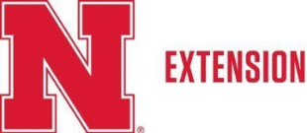
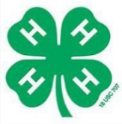

Request for Official Approval for Establishment of New 4-H Unit and Club Charter

Fields for Applicant
Date of Application: Click or tap to enter a date.
Name of Group: Click or tap here to enter text.
Type of Group: (Example: to carry out a 4-H Bicycle Care and Safety Program or to carry out a continuous 4-H club program serving the need of youth in the community, providing them a variety of 4-H projects and learning opportunities)
Click or tap here to enter text.

Volunteer Leader or Other Person in Charge of 4-H Unit Name:
Click or tap here to enter text.
County: Click or tap here to enter text.
Complete Mailing Address
Address: Click or tap here to enter text.
City: Click or tap here to enter text.
State: Click or tap here to enter text.
Zip: Click or tap here to enter text.
Phone Number: Click or tap here to enter text.
Email Address: Click or tap here to enter text.
Submit form to 4-H Club Charter Requests (mailto:4hclubcharter@unl.edu)

Fields for State 4-H Program Administrator
Official Approval for New 4-H Unit
On the basis of the above purpose(s), the Click or tap here to enter text. is authorized to use the 4-H name and emblem in connection with its program and activities and is considered an official 4-H unit of the Click or tap here to enter text. Extension program.
Click or tap here to enter text.
State Program Administrator
Click or tap here to enter text.
Date

