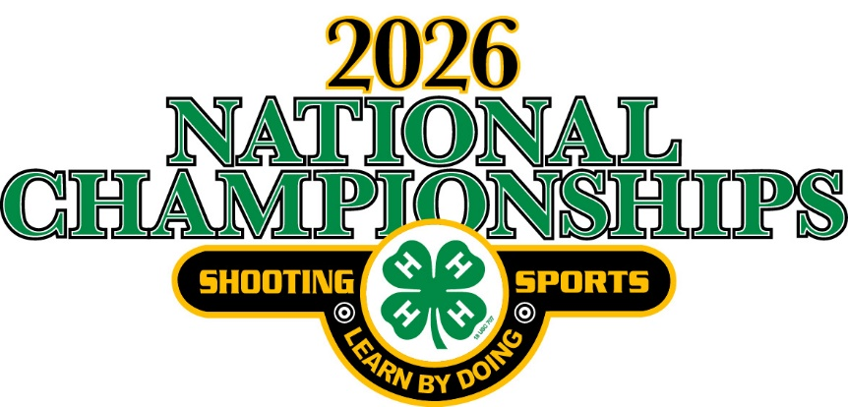

Welcome to the 4-H Shooting Sports National Championships

The University of Nebraska – Lincoln & Nebraska 4-H Youth Development Program welcomes you to the 2026 4-H Shooting Sports National Championships! It’s through the efforts and leadership of many volunteers from across the country that enables this national 4-H event to be held and a positive experience for our youth.

Nebraska 4-H and the National 4-H Shooting Sports Committee is extremely excited to host the 2026 event in Grand Island. This year marks America’s 250th Anniversary!. The theme of the Teen Social on Tuesday night is “Party in the U.S.A.” and the committee is planning a few special events and activities to commemorate the occasion during the Teen Social.

Currently there are not any direct health requirements for this event. Please be aware, based on any new directives or guidelines mandated or given by federal, state and/or local government these guidelines may be updated prior or during the event. There are also several areas in and around the Grand Island area with road construction to be aware of this year (South Locust, Stolley Park Road, and Hwy. 30).

We are providing this information packet to make your trip planning a little smoother. Enclosed you will find helpful information such as maps, directions, web links to lodging information, area entertainment and attractions, and other details that will make your stay in Grand Island an enjoyable one for the entire family.

Please do not hesitate to contact any of the following offices if you need any assistance in planning your trip to Grand Island. We are here to assist you in any way we can.
- Nebraska State 4-H Office - 402.472.2805
- Grand Island/Hall County Convention & Visitors Bureau - 308.382.4400

We are looking forward to seeing some familiar faces and lots of new faces in June!
Best Wishes,
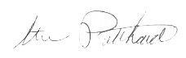
Steve Pritchard, Match Director
Event Expectations

The Championships is a youth event highlighting a major component of the 4-H program in individual states and nationally. Its nature demands that all of us involved in the event from the match directors and state coordinators to the young people, parents and coaches participating must put forward the best image of the 4-H Shooting Sports Program and the 4-H program. To protect that public image, use of alcoholic beverages and any use of tobacco products by minors is not permitted on the grounds of the Championships. Violation of this policy is grounds for disqualification and dismissal from the Championships.

Indoor Events/Activities
- All Ceremonies: Seating will be assigned for competitors and coaches by state. All spectators, family members, etc., will be seated where space allows.
- Ceremony Celebration – Due to possible personal injury to spectators and participants, there will be NO throwing, tossing, or discharging of any items or devises during the opening ceremony parade of participants, or during awards ceremonies.
- Fan/Spectator Support Items – The following items will NOT be allowed as fan/spectator support items at the Championships: artificial noisemakers, (including but not limited to horns, cow bells, bells, buzzers, shakers, clickers, thunder sticks, rattles), compressed air horns/sirens, and whistles. Sportsmanship, cheering, and support from the team are encouraged.
- Awards will be presented to individuals placing 1st through 10th as they cross the stage. (Individuals, 1st, 2nd, and 3rd will proceed to the Official Photo area). All others exit stage and return to their assigned seating area.
- Team Awards will be presented to the 1st, 2nd & 3rd place teams in the discipline. These teams will exit the stage to the Official Photo area.
- Photos – Official individual & team photos will be taken as awards are presented. A second photo backdrop will be available for states & families to take pictures.

Registration

Requirements:
Registration information and forms have been sent to State 4-H Shooting Sports Coordinators. Please contact your state coordinator for more details and information.

Other information and details can be found on:

4-H Shooting Sports National Championships webpage

The State 4-H Shooting Sports Coordinator or designated person in your state is responsible for completing your registration using an on-line process. Registrations will only be accepted through the online registration site. The registration fee is $325 per competitor for all disciplines. Registration must be completed by 11:59 pm CT, May 20, 2026. Registrations received between May 21 and June 5th will be charged a late fee of $400 per competitor for all disciplines. There is no fee for coaches. Only payment by credit card will be accepted unless previous arrangements have been made. Registration closes on June 5th, 2026, and no late entries will be accepted. All entry fees must be paid in full by June 5th, 2026.

Media consent will be completed by your State 4-H Shooting Sports Coordinator or designated person as a part of the online registration process. When your State 4-H Shooting Sports Coordinator, or designee, registers you for competition, you are agreeing to give the National Shooting Sports Committee, its partners, agents and representatives to use, publish, and republish for purposes of advertising, public relations, trade, or any other lawful use – public information and photograph, film, audio/video tape, record and/or televise participant's image and/or voice for use in publications or promotional materials without any restrictions. You are waiving any right that you may have to inspect or approve the copy and/or finished product(s) that may be used in connection therewith or the use to which it may be applied without any expectation of compensation. Media consent must be completed and submitted to your State Coordinator for each participant and coach. Since each state may have a different collection process, your State Coordinator will be communicating to you how your state will collect and submit the Media Consent. A substitute/alternate must also complete a Media Consent to participate at the National Championships. If an individual declines Media Consent, it will be the responsibility of the State Coordinator or designated person to inform the individual that they cannot participate in state team photos or any official awards ceremony photos taken during the current year’s event. In addition, an individual who declines Media Consent assumes personal responsibility as this event involves a large public presence as well as media representatives photographing at ranges and other activities associated with the National Championships.

All registered participants and coaches will receive a complimentary 2026 4-H Shooting Sports National Championships t-shirt and souvenir pin. T-shirts will be available for pickup at the registration office. All t-shirts must be picked up at the registration office by 5 p.m. on Monday, June 22nd.

Updates for 2026

New for 2026
- MegaLink Scoring System, operated by CMP staff, will be used for both air rifle and air pistol.
- Air Rifle Silhouette practice – half of the teams will practice on Monday and the other half will practice on Wednesday afternoon. Practice times will be posted on Sunday.
- All competitors and coaches competing at the Heartland Public Shooting Park must sign a Waiver and Release of Liability form confirming their understanding of the rules and responsibilities while at the Heartland Public Shooting Park.
https://heartlandpublicshootingpark.com/about/waiver/
- NO battery operated hearing protection devises allowed on any range.
- Champion Shooting Glasses or glasses of similar design are not allowed
- All volunteers must be 14 years of age on January 1st of 2026 or older to volunteer their services at the Championships.

Reminders for 2026
- Coaches and competitors are reminded to check their specific discipline section in this Synopsis for NGB version of rules that will be implemented this year.
- All shotguns used by competitors must be equipped, fitted, and utilized so as not to eject empty shells in a manner that substantially disturbs or interferes with other competitors.
- Shotgun events on Tuesday will start at 9 a.m. Shotgun events on Wednesday and Thursday will start at 8 a.m.
- Trap, Sporting Clays and Skeet will be mixed squadding. Competitors will not shoot with anyone from their own state.
- Two models of Air Pistols or any facsimile thereof (break open pistols) are NOT allowed in this event for safety reasons: Air Venturi V10 Target and Stoeger XP4.
- The Orion Scoring System and target will be used in Smallbore Rifle 3-P event.
- In Air Rifle Silhouettes a competitor with only one rifle will be allowed to mount their scope and check for zero on a 15-meter Range Wednesday after their 10-meter event is finished. Contact Mike Jochum.
- No golf carts, ATV’s, club cars, or similar vehicles will be allowed on the 3D and field archery ranges during competition.

Teen Social
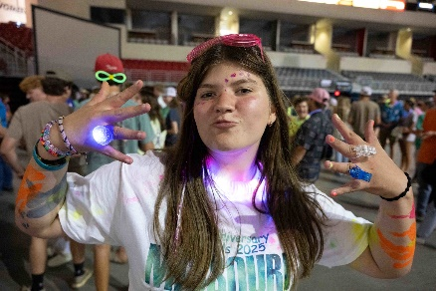
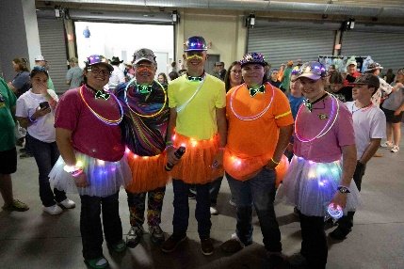
The National 4-H Shooting Sports Ambassadors would like to invite all Championship competitors to the teen social on Tuesday, June 23rd, 7-9 pm at the Heartland Event Center. The National 4-H Shooting Sports Ambassadors and Grand Island Convention and Visitors Bureau are hosting the Teen Social. Plan ahead to attend the “Party in the U.S.A.” teen social to have an evening of fun while in Grand Island. This is also the night that youth exchange state pins. Note there will be a snack bar available,
but payment by card only, no cash accepted.

Getting Here

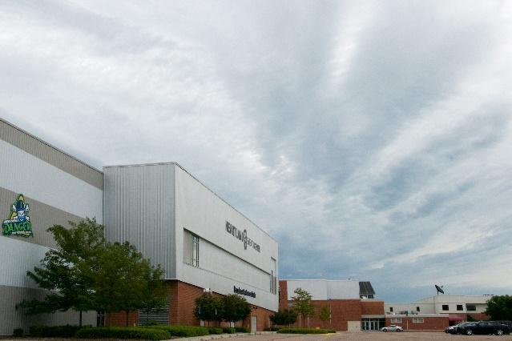
The Heartland Events Center is located on Fonner
Park, 700 E. Stolley Park Road, and approximately
10 minutes north of I-80. Registration, equipment
check-in, opening ceremony, evening awards, and
final awards will take place in the Heartland Events
Center except air pistol, air rifle, and archery
check-in. See schedule.

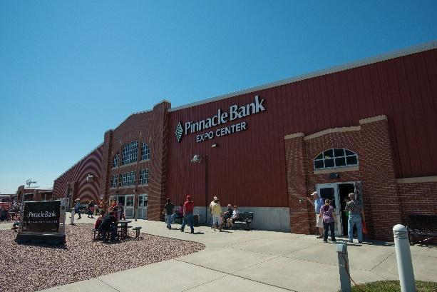
The Pinnacle Bank Expo Center, a 100,000 sq. ft. structure, is located directly west of the Heartland Events Center. It will be the site for all air rifle and air pistol competitions.

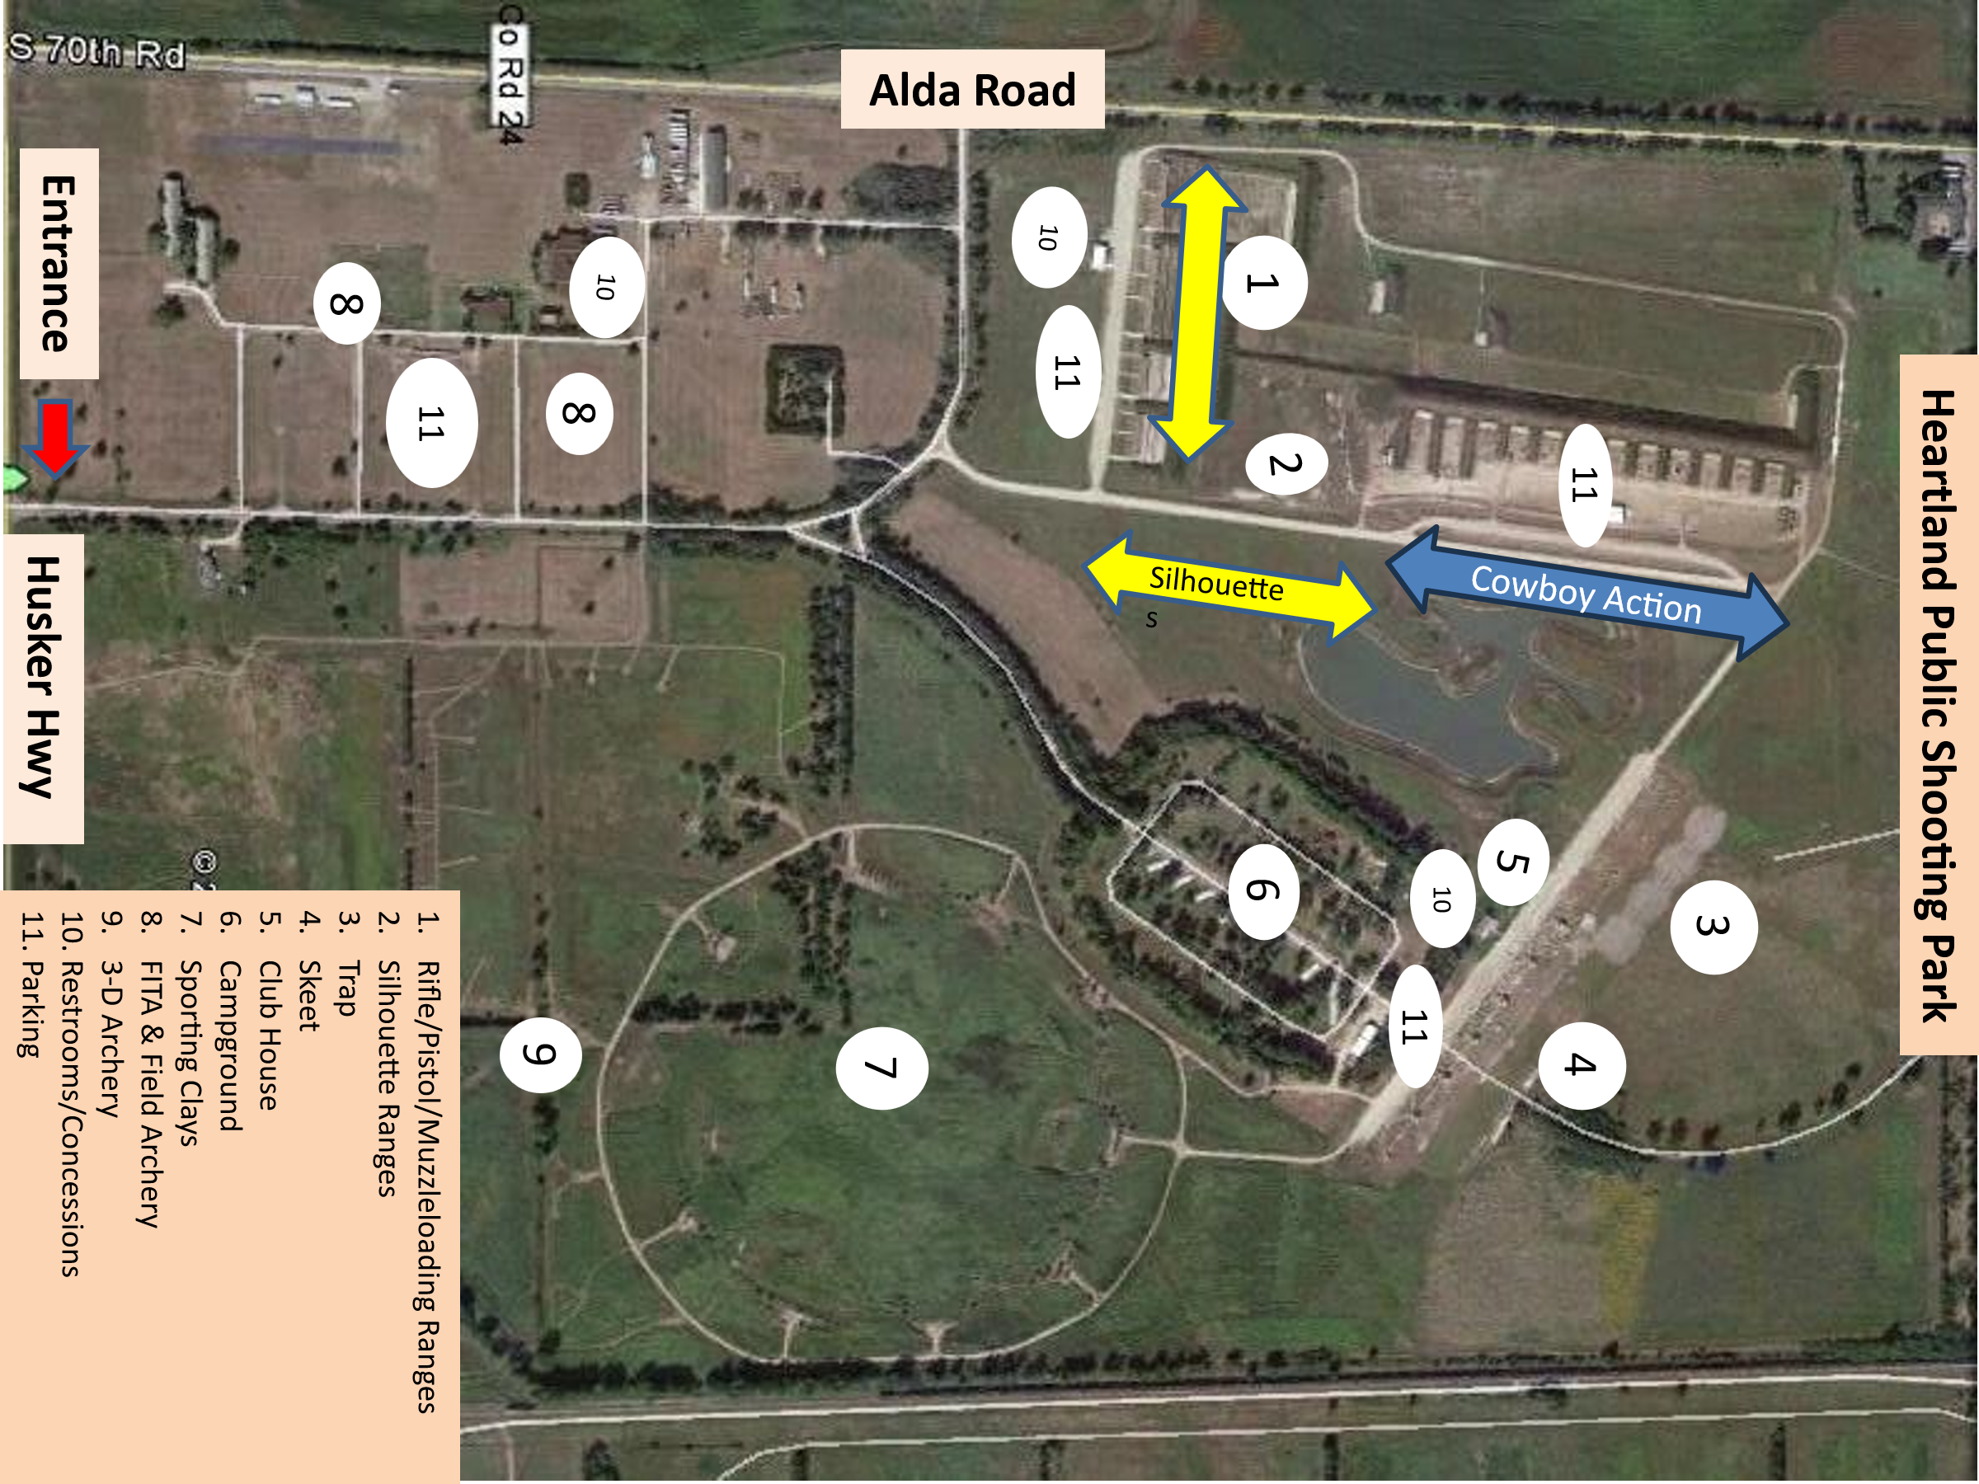
The Heartland Public Shooting Park
(HPSP) is approximately 10 minutes West
of Fonner Park. Directions to HPSP from the
intersection of Hwy 281 and Hwy 30
travel west/southwest on Hwy 30 approximately
2 miles to the Husker Hwy exit. Turn right onto Husker
Hwy and travel west for approximately 2 miles.
The entrance and signage will be on the north side
(right) of Husker Hwy.

2026 Fonner Park Access
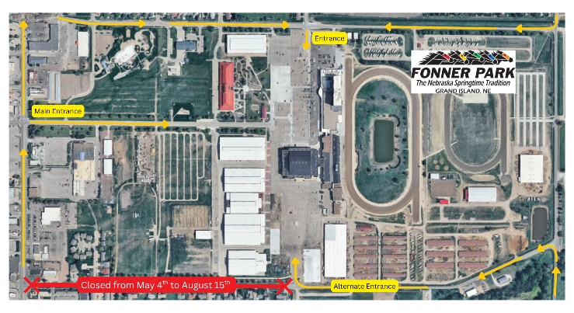
Note the construction this year on the south side of Fonner Park. Please use an alternate entrance.

Lodging

Hotels & Campgrounds

The Grand Island area offers many hotels and beautiful campgrounds. Use the link below to access the latest available hotel and campground information.

https://visitgrandisland.com/plan-a-trip/places-to-stay/

If needed, contact the Grand Island Convention & Visitors Bureau at:
(308) 382-4400 or Email - info@visitgrandisland.com

Fonner Park also has campgrounds available. Reserve a space by contacting Kathy Foley at kfoley@fonnerpark.com or 308-382-4515, ext. 213. The fee will be $40.00/night and must be made in advance. Space will be provided on a "reservation first" basis only. They will need to provide the nights they need to be reserved along with their permanent mailing address and phone number. A $5.00 per day cancellation fee applies. Payment will be made to Fonner Park and mailed to 700 E Stolley Park Rd, Grand Island, NE 68801.

Places to Eat

Dine around the world in Grand Island, from meat and potatoes to international cuisine. You will find stone oven pizza, gourmet burgers, Nebraska steaks, homemade pies, and old-fashioned malts. Relax and enjoy award winning Nebraska wines and specialty coffees. Most of these food venues are within 10 minutes of the Heartland Events Center. For large groups, advanced planning is needed. Please call ahead to book. https://visitgrandisland.com/plan-a-trip/places-to-eat.html

Grand Island dining options for large groups (20+)

Location | Location
Chicken Coop | Texas Roadhouse
120 E 3rd St | 232 Wilmar Ave
308-398-2500 | 308-382-0526
The Chocolate Bar | Olive Garden
116 W 3rd St | 1010 Allen Dr
308-675-0664 | 308-384-1277
Napoli's | Texas T-Bone
3333 Ramada Rd | 1201 S Locust St
308-675-1771 | 308-382-9474
Sutter Deli | Pizza Ranch
371 N Broadwell Ave | 1016 Diers Ave
308-370-8942 | 308-675-3044
Balz | Bandits
3421 W State St. | 1016 Diers Ave. Suite 118
308-398-2259 | 308-382-9333
Buffalo Wild Wings | Images Bar & Grill
809 Allen Dr. | Ramada Midtown Conference Center
308-381-7983 | 800-548-5542
Medina Street Vault | Everest Indian Kitchen
223 S High St | 316 N Pine St.
308-485-1058
Perkin’s Family Restaurant | Red Lobster
106 Wilmar Ave. | 3420 W 13th St.
308-384-7060 | 308-382-8879
Valentino’s Restaurant | Whitey’s
2245 W Webb Rd. | 2118 N Webb Rd.
308-382-7711 | 308-675-1151

- The City of Grand Island can reserve picnic shelters in several area parks. (308) 385-5444 ext. 290
- Fonner Park has several rooms available for group use. (Must use one of their facility approved caterers). Contact Amanda Duval (308) 382-4515.
- The Nebraska State Fair building located on the north side of Fonner campus has rooms for rent. Call: (308) 382-1606.
- Raising Nebraska is located on the ground floor of the State Fair Building. Their space is available for rent. Call: (308) 385-3967.
- Contact Grand Island Convention and Visitors Bureau for additional assistance (308) 382-4400.

Photography

Action Shots
There will be photographers on site capturing daily shooting events. Every attempt will be made to upload the photographs to the 4-H Shooting Sports National Championships web site on a nightly basis. Results & Photos

State Team Pictures
Each state team will have an opportunity to have their team photograph taken at the Heartland Events Center on Monday, June 22nd. The photographs will be available on the 4-H Shooting Sports National Championships website - Photos
The schedule for team pictures is as follows:

- 7:30-8:30 a.m. State Team pictures – Only invited teams at this time
- 3:00 – 4:00 p.m. State Team pictures for states beginning with letters A-M
- 4:00 – 4:45 p.m. State Team pictures for states beginning with letters N-S
- 6:15 – 7:00 p.m. State Team pictures continue for states beginning with letters T-W

Teams should plan to arrive 10-15 minutes before their appointed time.
Range Accessibility

The Heartland Public Shooting Park allows use of golf carts, ATV’s, club cars, and similar vehicles on site. Individuals can rent two seat golf carts from the Heartland Public Shooting Park for a fee of $60 per day. There are no half day rentals. Contact the Heartland Public Shooting Park (308.385.5048) directly if you are interested in renting a golf cart. Carts are available on a first come, first served basis. Operators of all vehicles at the Heartland Public Shooting Park must be 18 years of age or older and hold a valid driver’s license. Violation of this rule is grounds for disqualification for any individual or team involved. No golf carts, ATV’s, club cars, or similar vehicles will be allowed on the 3D and Field archery ranges during competition except designated Range Officials.
Area Attractions

The city of Grand Island and Hall County offers attractions for the diverse interests of visitors. The Grand Island Convention & Visitors Bureau website contains helpful information for visitors planning their trip to the area. Please visit their website at –
https://visitgrandisland.com/
Contacts for Gun & Bow Repair

GUN REPAIR
Wade Bentley – Cairo NE (308) 379-6635 (cell)
G.I. Loan Shop, Inc., 1004 W 2nd St., Grand Island (308) 382-9573

GUN STORES
G.I. Loan Shop, Inc., 1004 W 2nd St., Grand Island (308) 382-9573
Boops Shooters, 407 W 3rd St #5, Grand Island (308) 675-1745
Sportsman's Warehouse, 3535 W. 13th St., Grand Island (308) 833-7400

BOWS, ARROWS, REPAIR AND SUPPLIES
Ultimate Strings and Archery Shop, 312 N. Elm, Grand Island (308) 380-3725
Summit Archery, 1207 West J Street, Hastings (402) 462-2510
Dick’s Sporting Goods, 2250 N. Webb Rd., Grand Island (308) 392-3226
Sportsman's Warehouse, 3535 W. 13th St., Grand Island (308) 833-7400

Silent Auction

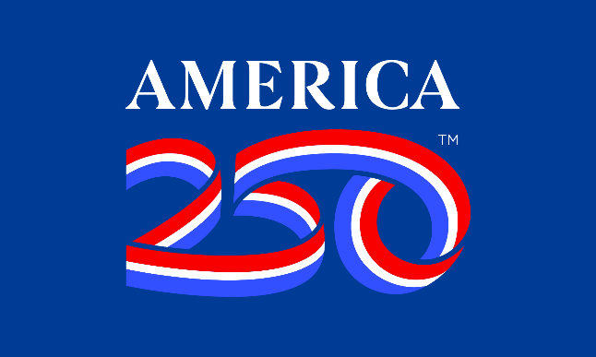
The popular silent auction will be held on Wednesday evening, June 24th. All states are invited to donate at least one item representing their state to put on the auction. This could be a gift basket, t-shirt, hat, or any item that is appropriate for an auction. Please turn items into the Registration Desk by 6:00 p.m., Monday, June 22nd or items can be shipped to arrive in Grand Island after June 15th but before June 19th. Address shipping label to read – Fonner Park, Attn: National 4-H Shooting Sports/Kyler, 690 E. Stolley Park Road, Grand Island, NE 68801.

Thanks for Attending the 2026
4-H Shooting Sports National Championships!

